  - HORIZON 2020
  - EUROPEAN DIALOGUE AND CLUSTERING ACTION
  - 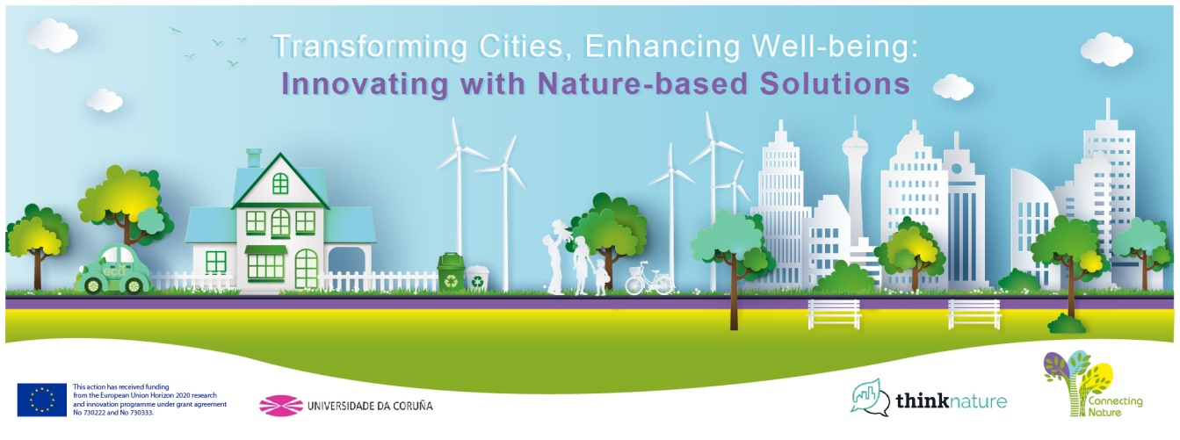

  - Transforming cities, enhancing wellbeing: innovating with nature-based solutions

University of A cORUNA (SPAIN),

16-18 May 2018

INSTRUCTIONS FOR POSTER PRESENTATION

Poster Presentation for Cities participating in the 2018 Horizon 2020 European Dialogue and Clustering Action (only one poster per city):

We ask cities to prepare a poster presenting one or several nature-based solutions that they have implemented (or in process to) in their cities and to share main lessons they have learned about challenges encountered and success factors.

There are specific times in the agenda dedicated to the posters, where participants can get to know the different nature-based solutions.

You have a choice of either using the template we provide, or making your own design. However, we recommend including the following information:

- Description of the nature-based solution
- Name of the nature based solution (NBS)
- Location (city)
- Goals of the NBS presented
- Photos illustrating the NBS intervention(s)

- Impacts and lessons learned
- Main impacts
- Main challenges encountered
- Any elements you identified that contributed to success
- Contact persons

You have the choice of either bringing the poster with you or having it printed here on site (we will help with that –posters will have to be paid upon pick-up and cost will vary between 10 and 15 Euros. All posters should have the following dimensions: DIN AO - 841×1189 mm (vertical orientation).

